

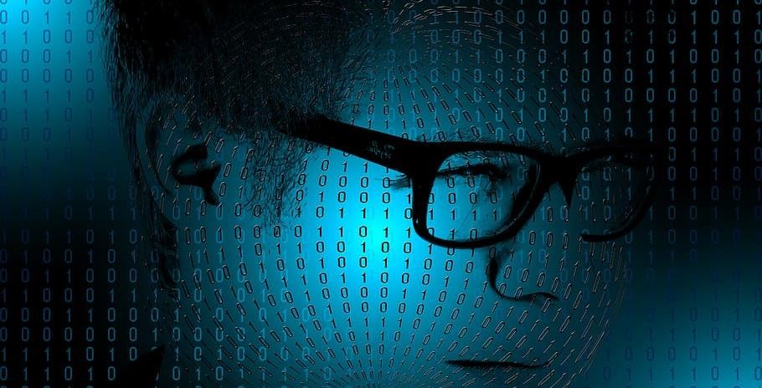

Hardware Networking

## TERM-1 Comptia A+ N+ Assignment

#### Module 1 [Hardware and its components] Topic: The Visible Computer

##### Assignment Level Basic

* 1. What is hardware?

Answer:-

Hardware refers to the physical elements of a computer. Also referred to as the machinery or the equipment of the computer. Examples of hardware in a computer are the keyboard, the monitor,

the mouse and the processing unit However, most of a computer’s hardware cannot be seen;

It’s inside the computer case.

2.What is the purpose of Hardware?

Answer:-

The purpose of hardware is to communicate with the system by providing input through

input devices, storing data, processing information, providing results through output

devices etc.

##### Assignment Level Intermediate

* 1. list out two types of hardware.

Answer:-

The two types of hardware are:-

Internal hardware

Processor(CPU)

Motherboard

Hard Drive

Solid State Drive

RAM

External hardware

Keyboard

Mouse

Monitor

Speaker

WebCam

##### Assignment Level Advance

1. What is core hardware

Answer:-

A core is a processing unit of the CPU. It is responsible for executing programs and other multiple actions on a computer.

A core can be divided into THREE main parts: control unit, arithmetic-logical unit and memory. Each part is responsible for particular tasks.

**CONTROL UNIT** :- This unit enables the communication of the core with other components of a computer system. So, for example, it requires instructions processing, sends signals for the computer system hardware, and manages the computer system data. In this way, the control unit communicates with both

the arithmetic-logic unit and the memory.

**Arithmetic-Logic Unit** :- This unit consists of electronic circuits that execute arithmetic and logical operations. Usually, the ALU executes four arithmetic operations – addition, subtraction, multiplication, and division. Furthermore, it typically executes three logical operations – equal-to, less-than, and greater-than.

**Memory** :- The memory built within the core consists of registers and cache.

Resgisters are portion of memory used to, for example, keep addresses, instructions, and results of calculations for the core processing. Cache, in turn, is a high speed random-access memory that holds data that the core probably will use.

1. Do a practical of identifying hardware

Answer:-

* 1. Firstly, press windows key + R and type cmd, you will see windows powershell displayed on your screen.
  2. Secondly, type systeminfo command and press the enter key, the text will provide you with hardware details and all the necessary system details.

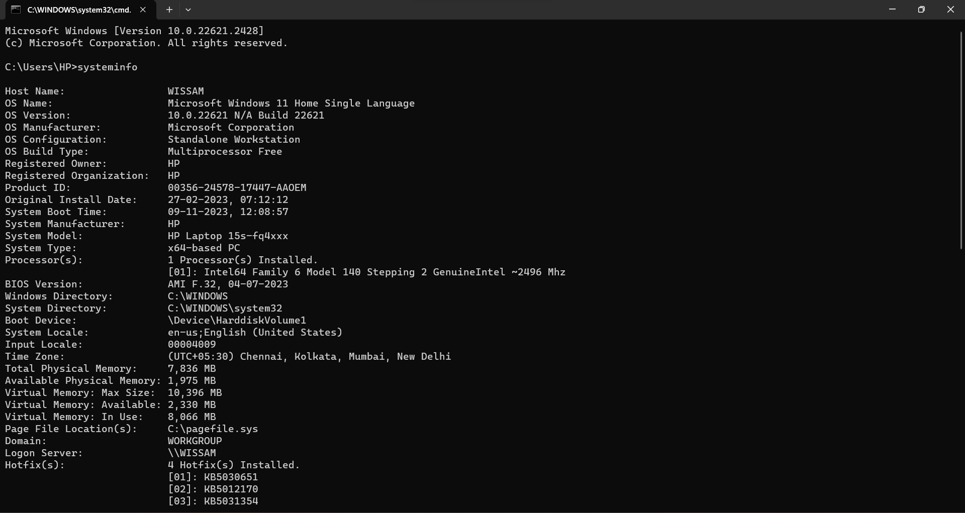

#### Topic: Category of components

##### Assignment Level Basic

1. What are the category of components in hardware?

Answer:-

There are FOUR main categories of hardware components:-

1. Input devices
2. Processing unit
3. Output devices
4. Storage unit
5. Why category is needed?

Answer:-

Categorization allows us to understand the relationship and connections between components in a much better way.

##### Assignment Level Intermediate

* 1. Do a practical to identify the components in which category they come.

Answer:-

1.The first category is of input devices, all these devices are in control of the user so that they can send information to the system.

Example:-Keyboard,Mouse etc.

2.In the category of processing unit, the components receive data signals from the input devices and performs necessary processes so that the computer can provide results. These components are placed on the motherboard as chips and slots for drives.

Example:- CPU, clock, cache etc.

3.Output devices receive the processed data which are results required to be given to the user, these devices are in control of the computer. Thes user receives the results in a form which is understandable to them.

Example :- Monitor, Speaker etc.

4.Storage unit, data which needs processing is stored here, it also stores intermediate results of any task. All sorts of inputs and outputs are transmitted through the memory unit.

Example :- RAM, cache, Hard drives etc.

#### Topic: Input Device

##### Assignment Level Basic

1. What is input device?

Answer:-

Input device is a computer hardware equipment which provides data and controls signals to the processing unit of the computer system. Example of input devices are keyboard, mouse, microphone etc.

1. Why input device needed?

Answer:-

Input devices are essential for functioning of the computer because it allows user to interact, feed data and instructions to it.

##### Assignment Level Intermediate

1. List out the input device.

Answer:-

There are many input devices available in the market. Some of them are as follows:-

* + - * + Keyboard
        + Mouse
        + Microphone
        + Scanner
        + Light pen
        + Joystick

1. Do a practical to identify input device and describe how it works.

Answer:-

All the devices which sends information to the processor to be processed and are in the control of the user is to be known as input devices.

Lets take an example of a keyboard.

A Keyboard is basically a character entry device which has different keys that provide different functions.

* HOW DOES A KEYBOARD WORKS?

A keyboard has its own circuit, processor and ROM, the circuit carries information to and from the processor in the form of charge. Underneath every key there is a conductor surrounded with insulators, when a key is pressed the circuit is sorted and the signal travels in the form of charge to the processor which in turn sends the signal to the CPU in the form of binary.

The keyboard is big matrix of circuit for every key, the memory unit has a character map which describes the function of every key to the processor.

#### Topic: Output Device

##### Assignment Level Basic

1. What are output device?

Answer:-

Peripheral devices which provides results to the user that has been processed by the processing unit in visual, audio or any other form.

1. how does output device work?

Answer:-

The output device receives data from the processing unit in form of signals and then

converts into a form which is easy for the user to understand, depending on the function

of the output device in question. It could be in a audio form for speakers, or in a visual

form for monitors.

##### Assignment Level Intermediate

1. List out the output device.

Answer:-

There are many output devices. Some of them are as follows:-

* + - * + Monitor
        + Speaker
        + Printer
        + Headphones
        + Projector
        + Webcam

1. Do a practical to identify the output device and describe its working process.

Answer:-

All the devices that are in control of the computer and provides results to the user are output devices

**WORKING PROCESS OF PRINTER**

A printer works by sending electronic signals from the computer to the printer's control board. The control board then interprets these signals into instructions for the print head or toner cartridge. The print head or toner cartridge prints the document or image onto paper.

#### Topic: Motherboard

##### Assignment Level Basic

1. What is motherboard?

Answer:-

The main circuit board of a system. All the peripheral devices and components are connected to it.

1. Why it is called motherboard?

Answer:-

It is called motherboard because it is the main circuit board of the computer and it is the mother of all components.

##### Assignment Level Intermediate

1. What it is called if we remove all components from the motherboard?

Answer:-

Printed circuit board

1. Describe types of motherboard.

Answer:-

There are 2 types of motherboard, Integrated and non-integrated.

* Integrated motherboard:-

An integrated system board has multiple components integrated into the board itself. These may include the CPU video card, sound card and various controller cards.

* Non-integrated motherboard:-

Non-integrated system board uses installable components and expansion cards. For example, non integrated system board may allow you to upgrade the video card by removing the old one and installing a new one. Non integrated motherboard typically have server PCI expansion slots as well.

##### Assignments level Advance:

1. Do a practical by identifying parts of motherboard.

Answer:-

1.Firstly, we will take a motherboard as shown in the picture.Now, we can see there are various interfaces attached on one side. This interfaces allows the system to connect with i/o devices.

The ports that we can see in the image are

1. PS-2 port(keyboard and mouse)
2. 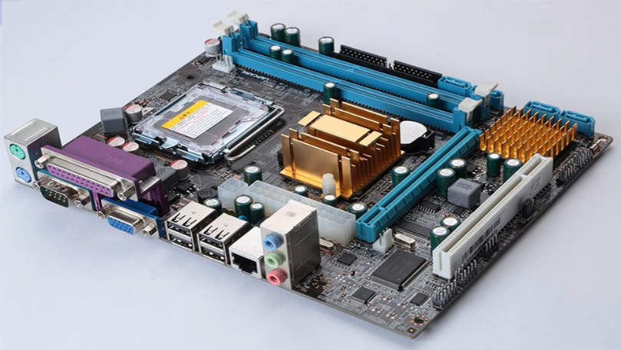Serial port(router)
3. DVI port(printer)
4. USB port
5. LAN port
6. Sound card

2.Secondly, we can see an ATX port for power supply, SATA port for SSDs, IDE for PATA hard disk

3.we can also see a RAM slot, then a PCIe slot for graphics card and standard PCI slot for any external card.

4. heat sink to absorb heat and keep the system safe.

5.last but not the least, the main CPU socket.

1. Do a practical by describing the data flow in motherboard

Answer:-

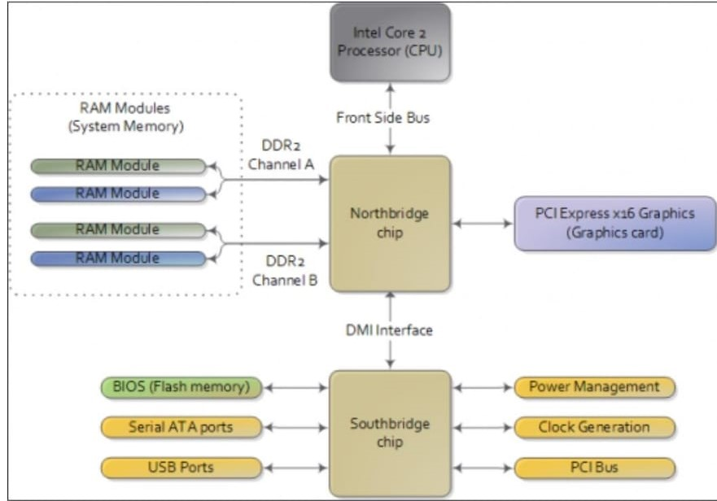

1.The northbridge is in direct contact with the CPU,PCIe slot and RAM, so everything related to them has to travel through the northbridge to the CPU.

2.the standard PCI slots, other interfaces and ports for peripheral devices to interact with the system.

3.The data travels through the southbridge, the northbridge and then the CPU.

1. Do a practical by removing all removable parts from the motherboard.

Answer:-

* Firstly, disconnect all the peripherals and open the case.
* Unscrew your motherboard and take it out.
* Now, slowly and carefully you have to remove all the hardware attached.
* Remove the video card.
* Remove the sound card.
* Remove the network card.
* Remove the hard drive by disconnecting all the cables.
* Remove the RAM from the RAM slot.
* Remove the heatsink and the cooling fan.
* Remove the CPU carefully from the slot.
* Disconnect and remove the cd-rom or dvd-rom drive if connected.
* Disconnect the main atx power cable.
* Disconnect any sata or ide connection.
* Also remove the cmos battery.

#### Topic: CPU

##### Assignment Level Basic

1. What is CPU.

Answer:-

CPU is known as the brain of a computer system. It performs all type of data processing

operations, it stores data, intermediate results, and instructions, it controls the operations

of all the parts of the computer.

1. Write the full form of CPU.

Answer:-

The full form of CPU is CENTRAL PROCESSING UNIT.

##### Assignment Level Intermediate

1. What are the types of CPU?

Answer:-

There are 3 types of CPU

* LGA
* PGA
* BGA

1. What do we need to keep the CPU Healthy?

Answer:-

If we keep our computer well-maintained and healthy by taking preventive measures,

we can keep the computer safe from many viruses and malware.

##### Assignment Level Advance

1. Do a practical to remove processor and apply thermal paste in it and install it again.

Answer:-

1.Firstly, separate the hestsink from the top of the processor, use a tissue and clean off the thermal paste from the top.

2.There is a latch which fixes the processor, unlatch it and gently remove the CPU.

3.to reinstall, match the notch and fix it on the socket properly, handle carefully because you don’t want to bend the pins.

4.lock the processor with the latch on the socket

5.Apply thermal paste on the top of the CPU.

6.Fix the heatsink on the top.

1. Do a practical to Identify CPU and its Sockets.

Answer:-

There are 3 types of CPU and CPU sockets

1.LGA – Land Grid Array

In this type, the processor is pinless and the socket is pinned.

2.PGA – Pin Grid Array

In this type, the processor has pins and the socket is pinless.

3.BGA- Ball Grid Array

The sockets have small spherical spaces and the processor has small metallic balls.

#### Topic: Monitor

##### Assignment Level Basic

* 1. What is Monitor?

Answer:-

Monitor is an output device that displays results on its screens for the user to see.

##### Assignment Level Intermediate

1. List out the types of monitor.

Answer:-

The types of monitors are as follows:-

* CRT monitor
* LCD or Flat-Panel monitor
* Ebook reader
* Data projectors
* High definition Television

1. Do a practical to identify monitor Technology.

Answer:-

1. If your monitor is bulky and has a standard aspect ratio, then the monitor uses crt technology.
2. If your monitors form factor is light and slimmer, it probably uses LCD technology or LED. To differentiate between them, the backlighting source should either be fluorescent light tubes or smaller LEDs.

1. What are the Technologies used in monitor.

Answer:-

* + Cathode Ray Tube
  + Liquid Crystal Display
  + Light Emitting Diode

##### Assignment Level Advance

* 1. Describe how does the crt monitor works.

Answer:-

* Contains a cathode consisting of thick heated wire that is covered with a glass tube, which is vacuum sealed to eliminate resistance.
* Cathode emits stream of electrons into the tube and travels down its length.
* These electrons are attracted and accelerated by anode (positive terminal).
* After getting high speed they are strucked to phosphorescent screen at the end of tube.

• This causes to glow that part.

* String coils consists of copper wire wrapped around the picture tube itself, to create magnetic fields that steer the electron beam to distinct pixel on the screen.
* This group of distinct pixels form an image on the screen.
* Color tv uses three electron beams at once.

#### Topic: system bus

##### Assignment Level Basic

* 1. What is system bus

Answer:-

A system bus is a single computer bus that connects the major components of a computer system, combining the functions of a data bus to carry information, an address bus to determine where it should be sent or read from, and a control bus to determine its operation.

##### Assignment Level Intermediate

1. List out the types of system bus.

Answer:-

There are 3 types

* Address bus
* Data bus
* Control Bus

2.Describe the working of system bus.

Answer:-

The system bus connects the CPU with the main memory and, in some systems, with the level 2 (L2) cache. Other buses, such as the IO buses, branch off from the system bus to provide a communication channel between the CPU and the other peripherals.

The system bus combines the functions of the three main buses, which are as follows:

* The control bus carries the control, timing and coordination signals to manage the various functions across the system.
* The address bus is used to specify memory locations for the data being transferred.
* The data bus, which is a bidirectional path, carries the actual data between the processor, the memory and the peripherals.

3.Do a practical to identify the system bus.

Answer:-

System bus is the pathway through which signals move to communicate with cpu.

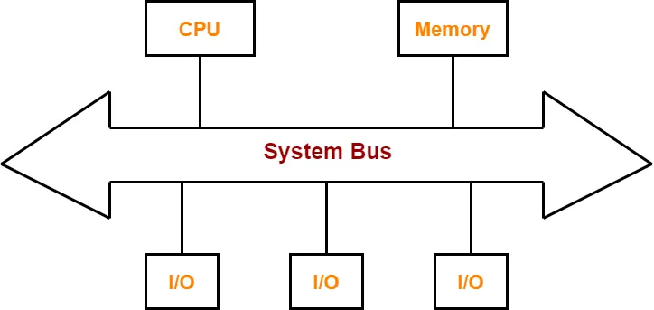

System bus has 3 components which are address bus, control bus and data bus.

Together they perform functions in the system so that the components can perform their work.

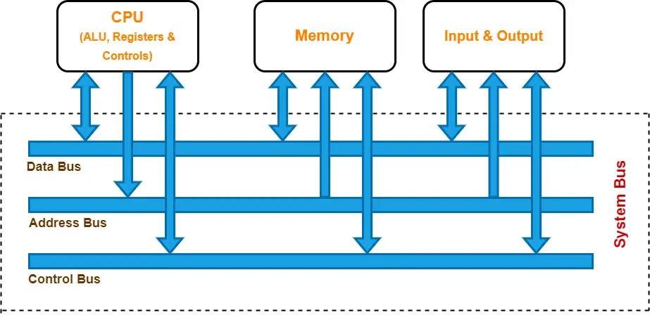

#### Topic: Chipset

##### Assignment Level Basic

* 1. What is chipset

Answer:-

A collection of electronic components that work together to enable the functioning of a computer system. A set of IC is called a chipset.

##### Assignment Level Intermediate

1. What are the types of chipset?’

Answer:-

There are 2 types

* North bridge
* South bridge

1. Which chipset does have direct contact with the cpu.

Answer:-

North bridge has direct contact with cpu.

1. Do a practical to identify the chipset

Answer:-

1.On the motherboard, chipset manages the flow of data between components of motherboard

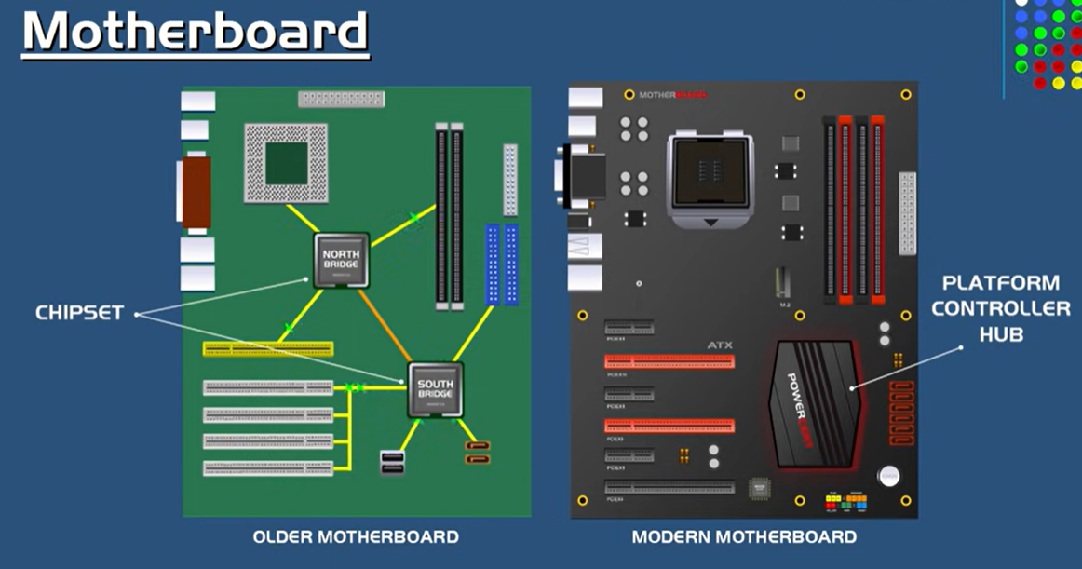

1. We can see that in the older motherboard, there were two chips northbridge and southbridge through which the data used to flow. But in newer versions there is an integrated chip that does the same work.

##### Assignment Level Advance

* 1. Describe how does the Northbridge chipset work

Answer:-

The northbridge is in direct contact with the CPU, and it handles connections between the CPU,memory and PCI slot for the graphics card. The other connection is with the southbridge which is in contact with various SATA ports and other PCI slots.

#### Topic:Memory

##### Assignment Level Basic

1. What is memory?

Answer:-

Computer memory stores information, such as data and programs for immediates usage in the computer. The term memory is often synonymous with the term primary storage or main memory.

1. What are the types of memory?

Answer:-

There are 3 types of memory:-

* Primary memory:-
* Secondary memory:-
* Cache

##### Assignment Level Intermediate

1. Describe memory in detail.

Answer:-

* Primary memory:-

Also known as main memory in computer, it communicates directly with the CPU, Cache and Auxiliary memory. This type of computer memory keeps data and programs when the process is active to use them. It includes memory drives like RAM and ROM.

* Secondary memory:-

It is a permanent type of memory in computer that holds a large amount of data. This is an external memory that represents different storage media on which data and programs can be saved for long term. It is not directly accessible by the CPU and is available as external devices such as CDs, DVDs and USBs. They are cheaper than primary memory but slower than primary memory.

* Cache

This small-sized chip-based memory in computer lies between the main memory and CPU. It is very close to the chip of CPU. The aim of this type of computer memory is to enhance the performance of the CPU. It is a high-performance and temporary type of memory that reduces the access time of data from main memory. Every instruction and data that is often used by the CPU is stored within Cache memory.

1. What are memory types.

Answer:-

Types of main memory

* RAM
* ROM

##### Assignment Level Advance

1. Do a practical to identify memory types.

Answer:-

**IDENTIFYIN RAM**

1.Firstly, you have to remove your motherboard from the system unit.

2.Secondly, you have to check your RAM slot and see the notches and have to identify the RAM that have notches that would fit in the slot.

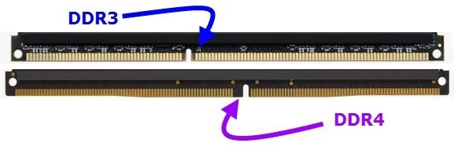

3.The slot also has a mark on which the voltage required is written, if the voltage is 1.8V then the RAM that will fit is DDR2.

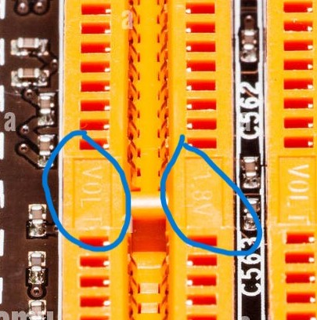

4.you can also identify by the number of pin slots on the ram slot.

**IDENTIFYING ROM**

1.To see a ROM, the computer device has to be dismantled as it is usually attached to the motherboard.

2. Once you have found the motherboard, you will be able to locate the ROM Chip by careful examination.

3. it is very common for manufacturers to install the ROM chip around the south bridge and peripheral card slots.

4. By close examination, the ROM chip can be identified by the text that is printed on it and the connection pins that attach it to the board. Most connection pins on ROM chips are often 28 or 30 in number, although there are a few instances where they are more than that. The manufacturer is at liberty to determine the number of pins they want to use.

5. the manufacturer’s name is boldly written on it. Sometimes, the word BIOS is used instead of the manufacturer’s name with some coded numbers written beside it.

1. Do a practical to install memories in system

Answer:-

1. **INSTALLING RAM**

* Firstly, you need to identify what type of Ram memory does your motherboard support and for that you need to dismantle your case and examine your circuit board.
* After identifying, carefully fix the ram chip on the slot.

1. **INSTALLING HARD DISK**

* Take your motherboard and identify the port(whether it is sata or pata) It is mostly sata nowadays, so we will assume it this way
* Now connect the sata data cable to the motherboard and the other end to the hard disk.
* And the sata power cable to the power supply and the other end to the hard disk.

1. Do a practical to identify main memory frequencies.

Answer:-

* Open windows tab, search task manager
* Click on task manager
* Click on performance menu
* Select memory
* You can see the frequency of your main memory on this page

#### Topic: System Unit

##### Assignment Level Basic

* 1. What is System Unit?

Answer:-

A system unit is the part of a computer that houses the primary devices that perform operations and produce results for complex calculations. It includes the motherboard, CPU, RAM and other components, as well as the case in which these devices are housed. This unit performs the majority of the functions that a computer is required to do.

##### Assignment Level Intermediate

1. How does system unit work?

Answer:-

The primary function of the computer system unit is to hold all the other components together and protect the sensitive electronic parts from the outside elements. It is also called computer case or computer chasis, the case has various slots and connector ports opening for peripherals to connect to the motherboard.

1. What are the components and system unity?

Answer:-

Some components of the system unit are as follows

* Microprocessor
* RAM
* Hard disk
* Motherboard
* CD drives
* Floppy drives
* Fan
* SMPS – Power supply

##### Assignment Level Advance

1. 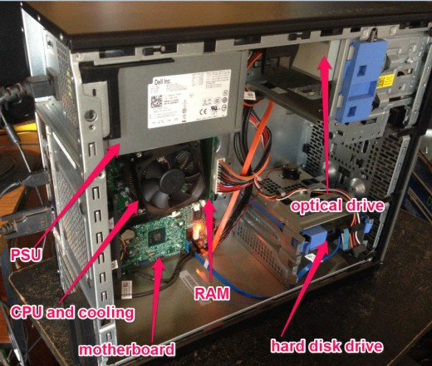Do a practical to identify system unit.

Answer:-

* Your system unit is your whole computer case in which you have a fan, motherboard, CPU, hard drives, optical drives, power supply unit and RAM.
* All the devices are in this case for protection.

1. Do a practical to assemble and disassemble system unit.

Answer:-

* ASSEMBLING

1. The First Step in Assembling a Computer Is to Open the Computer Case. To Open the Case, First Remove the Screws of the Left Side Cover and Slide the Side Cover.
2. The Next Step Is to Install a Power Supply. There Are Usually Four Screws That Attach the Power Supply to the Case
3. The Motherboard Has To Be Prepared Before Its Installation. To Prepare The Motherboard, You First Need To Install The CPU, Then The Heat Sink On The CPU And CPU Fan
4. A CPU Socket Uses A Series Of Pins To Connect A CPU’s Processor To The Pc’s Motherboard. If A CPU Is Connected Via A CPU Socket.
5. After Preparing The Motherboard, You Can Install In The Computer Case
6. The Hard Drive Is The Device Which Stores All The Data. Connect The Power Cable Coming From The SMPS To The Power Socket Of Hard Disk Drive. Connect SATA Data Cable From Hard Disk Drive Socket To The Motherboard Socket
7. Power Cables Are Used To Distribute Electricity From The Power Supply To The Motherboard And Other Components. Data Cables Transmit Data Between The Motherboard And Storage Devices, Such As Hard Drives.
8. The Advanced Technology Extended (ATX) Main Power Connector Will Have Either 20 Or 24 Pins.
9. Connect external cables to the computer.

* DISASSEMBLE

1. Unplug your system from all the peripherals
2. Remove side covers
3. Disconnect connectors
4. Remove standalone fans
5. Remove storage devices
6. Remove memory modules
7. Remove power supply unit
8. Remove motherboard adapter or expansion cards
9. Remove the motherboard

#### Topic: BIOS

##### Assignment Level Basic

* 1. What is bios.

Answer:-

BIOS is the program a computers microprocessor uses to start the computer system after it is powered on. It also manages data flow between the OS and other attached devices.

##### Assignment Level Intermediate

* 1. What is the full form of bios

Answer:-

Basic input/output system.

2.Describe working process of BIOS.

Answer:-

* BIOS is a program that is made accessible to the microprocessor on an erasable programmable read-only memory (EPROM) chip. When users turn on their computer, the microprocessor passes control to the BIOS program.
* When BIOS boots up a computer, it first determines whether all of the necessary attachments are in place and operational. Any piece of hardware containing files the computer needs to start is called a boot device. After testing and ensuring boot devices are functioning, BIOS loads the OS -- or key parts of it -- into the computer's random access memory from a hard disk or diskette drive (the boot device).

##### Assignment Level Advance

1. Do a practical to reset bios when system is on.

Answer:-

* While turning on your pc, repeatedly press f2,f4,esc etc(depends on system to system)
* You will find your monitor to display a boot menu, use your arrow keys and select enter setup.
* Now, to reset the bios tap f9 key. Select yes, your system has been reset.
* Tap f10 to save and exit.

1. Do a practical of Hard resetting the BIOS.

Answer:-

* You will find small pins near your CMOS battery, take a jumper and fix it on them.
* Wait for 2-5 mins and remove it.
* Your BIOS is reset.

1. Do a practical of identifying BIOS chip from the motherboard

Answer:-

* The EEPROM chip on the motherboard is the BIOS chip.

#### Topic: CMOS

##### Assignment Level Basic

1.What is CMOS?

Answer:-

CMOS is the term usually used to describe the small amount of memory on a computer motherboard that stores the BIOS settings. Some of these BIOS settings include the system time and date as well as hardware settings.

##### Assignment Level Intermediate

1. What is the full form of CMOS?

Answer:-

Complementary metal-oxide-semiconductor.

1. Describe the working process of CMOS.

Answer:-

CMOS works through an interplay between two transistors - an N-Channel MOSFET and the P-channel MOSFET. As soon as the N-channel MOSFET conducts, the P-channel MOSFET is simultaneously turned off and vice versa.

##### Assignment Level Advance

1. Do a practical of identifying cmos.

Answer:-

* The circular battery on the motherboard is CMOS.

1. Do a practical of installing cmos

Answer:-

* Take a CMOS battery and fix it on the motherboard to the battery slot which is in a circular shape.

1. How do we know that cmos is not working.

Answer:-

If the date and time of the system is changing repeatedly by itself, or the bios settings are changing back to default on its own. Then there is a high possibility that the cmos is not working.

#### Topic: Boot process

##### Assignment Level Basic

1.What is Boot Process?

Answer:-

Boot process is the process of starting a computer as initiated via hardware such as a button or by a software command.

##### Assignment Level Intermediate

1. What is the first process of boot?

Answer:-

 Once the computer system is turned on, BIOS (Basic Input /Output System) performs a series of activities or functionality tests on programs stored in ROM, called on POST (Power-on Self Test) that checks to see whether peripherals in the system are in perfect order or not.

1. What is the final stage in the boot process?

Answer:-

Full control of hardware and machine is granted to the OS so that it can look after all the operations.

1. Describe the boot process in Linux?

Answer:-

The Linux boot process is the sequence of stages the operating system goes through when it is started. During the boot process, the system's hardware is initialized, the bootloader is loaded, the kernel is loaded into memory, system services are created, and the user interface is presented.

##### Assignment Level Advance

1. Describe about working with the grub bootloader.
2. Describe working process of boot loader.

Answer:-

Bootloaders serve as a mediator between hardware and the operating system. As soon as a bootloader has been initialized by the respective firmware, it has system responsibility to get the boot process going. The first task is to load the main memory, which is essential for the processor to work.

In the second step, the bootloader loads the kernel of the operating system, that is, the primary component of the system software that controls all storage and processor permissions and contains all important drivers.

#### Topic: SMPS

##### Assignment Level Basic

1. What is SMPS?

Answer:-

An SMPS(Switch-Mode-Power-Supply) is an electric circuit that uses switching devices such as filter and rectifier at high frequencies to convert and provide the required voltage to the device which needs the supply of power.

1. What is the process of SMPS?

Answer:-

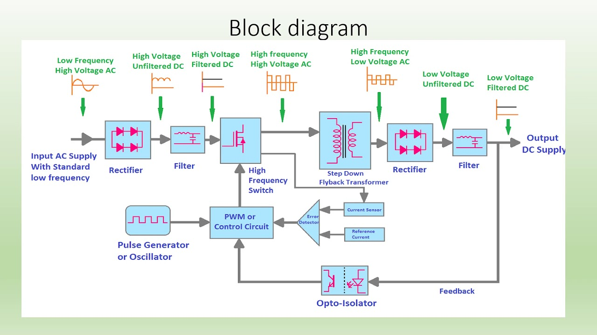

This diagram is the working of SMPS

* Firstly, Input of AC current at low frequency and high voltage is provided to the SMPS, it is passed through a rectifier which converts the ac current to dc. But this Dc is not pure dc and is mixed with attenuations.
* The signal is passed through filter so that we can get pure dc, and later through a switch which converts the signal into high frequency.
* The step down transformer makes the former high voltage current to low volatage.Next, the current passes through output pair of rectifier and filter to get the pure dc current and at the required voltage.
* If the voltage is more or less the current is passed through the feedback line and is processed again from the switch so that we can get the required voltage.

##### Assignment Level Intermediate

1. DO a practical to install SMPS.

Answer:-

SMPS is supposed to be installed to the motherboard, and every smps has various wires connected to it which provides power to different components of the motherboard.

1.Firstly, a 20+4 pin ATX main power connector is connected to the motherboard, then a secondary power connecter is connected which is of 4/8 pin to supply power to the CPU.

2.Next, PCI connector of 4 + 2 pins are connected for video cards or graphic cards on the motherboard.

3.SATA connectors are connected to Hard drives or solid state drives, the hard drive is always separate from the motherboard and it is connected with it to transfer data. The data cables are also SATA connectors and are connected with the SATA ports on the motherboard.

4. Molex connectors are also connected for fans and LEDs.

1. How many sata connectors are there in normal smps?

Answer:-

There are 4 sata connectors.

##### Assignment Level Advance

1. Do a practical to troubleshoot a smps without plugging it to the system.

Answer:-

* Open your computer case and take out the smps, unplug it completely.
* Take your atx connector, use a jumper and sort the green wire and black wire pins.
* If the smps doesn’t work then it is working properly.

1. How many pins does atx power connector have?

Answer:-

Atx power connector has 20 + 4 pin.

#### Topic: RAM

##### Assignment Level Basic

1. What is RAM?

Answer:-

is one of the most important parts of your computer. It provides high-speed, short-term memory for your computer's CPU. the technology allows the computer to temporarily store and access data immediately.

1. What is the full form of RAM?

Answer:-

Random Access Memory

##### Assignment Level Intermediate

1. What are the types of ram?

Answer:-

The types of RAM are as follows:-

* DRAM
* SDRAM
* SRAM

1. Do a practical to identify RAM.

Answer:-

1.Firstly, you have to remove your motherboard from the system unit.

2.Secondly, you have to check your RAM slot and see the notches and have to identify the RAM that have notches that would fit in the slot.



3.The slot also has a mark on which the voltage required is written, if the voltage is 1.8V then the RAM that will fit is DDR2.



4.you can also identify by the number of pin slots on the ram slot.

##### Assignment Level Advance

1. Do a Practical to identify ram and install it in a proper system.

Answer:-

1.Firstly, you have to remove your motherboard from the system unit.

2.Secondly, you have to check your RAM slot and see the notches and have to identify the RAM that have notches that would fit in the slot.



3.The slot also has a mark on which the voltage required is written, if the voltage is 1.8V then the RAM that will fit is DDR2.

#### Topic: Device and cable

##### Assignment Level Basic

1. What are the types of devices?

Answers:-

* Input devices
* Output devices
* Storage devices
* Processing devices

1. What are the types of cable?

Answer:-

There are many types of cables, some are as follows

* Coaxial cable
* Twisted pair cable
* Fibre optics cable

##### Assignment Level Intermediate

1. What cables are used to connect printer?

Answer:-

* DVI
* VGA
* HDMI
* Display port
* USB-C

1. What was the first cable founded by Apple for data transfer?

Answer:-

FireWire is the first cable founded by Apple for data transfer.

##### Assignment Level Advance

1. Do a practical to identify the sata cables.

Answer:-

if your hard disk is like the one in the picture, then it supports sata connection as there are two sata slots on it.

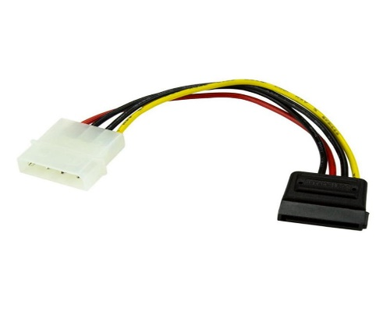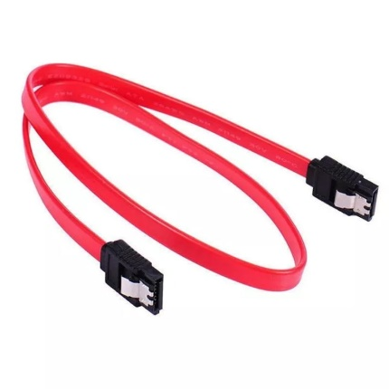

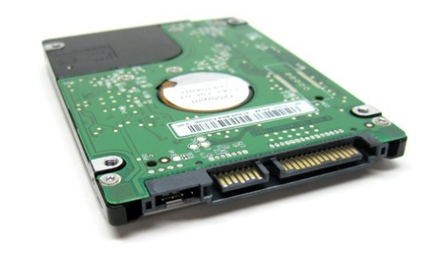

In both these slots you have to connect sata data cable, which is of 7 pin and a sata power cable which is of 15 pin.

1. Do a practical to identify and install the cables in the system.

Answer:-

**CONNECTING SMPS TO THE SYSTEM**

SMPS is supposed to be installed to the motherboard, and every smps has various wires connected to it which provides power to different components of the motherboard.

1.Firstly, a 20+4 pin ATX main power connector is connected to the motherboard, then a secondary power connecter is connected which is of 4/8 pin to supply power to the CPU.

2.Next, PCI connector of 4 + 2 pins are connected for video cards or graphic cards on the motherboard.

3.SATA connectors are connected to Hard drives or solid state drives, the hard drive is always separate from the motherboard and it is connected with it to transfer data. The data cables are also SATA connectors and are connected with the SATA ports on the motherboard.

4. Molex connectors are also connected for fans and LEDs.

**CONNECTING PERIPHERALS**

Your motherboard has various interfaces for peripheral devices to connect with the system.

1.you can install, keyboard and mouse with a ps-2 connector cable on the ps2 port.

2.connect with the internet using an ethernet cable with the LAN card.

3.connect printer using a usb-c cable.

4.connect speakers with the sound card.

#### Topic: Expansion card and slots

##### Assignment Level Basic

1. Why expansion card needed?

Answer:-

The primary purpose of an expansion card is to provide or expand on features not offered by the motherboard.

1. Why expansion slots needed?

Answer:-

An expansion slot is a socket on a computer motherboard that allows you to add additional components to your system. These slots are used to expand the capabilities of your computer and can be used to add new functionality to your system.

##### Assignment Level Intermediate

1. What are the types of expansion card?

Answer:-

Video card, Sound card, network interface card, Ethernet card, Accelerator card, Video capture card, TV Tuner card are some of the cards used in a computer.

1. What are the types of expansion cards?

Answer:-

Video card, Sound card, network interface card, Ethernet card, Accelerator card, Video capture card, TV Tuner card are some of the cards used in a computer.

##### Assignment Level Advance

1. Do a practical to identify the types of expansion slots

Answer:-

**PCI slot –**

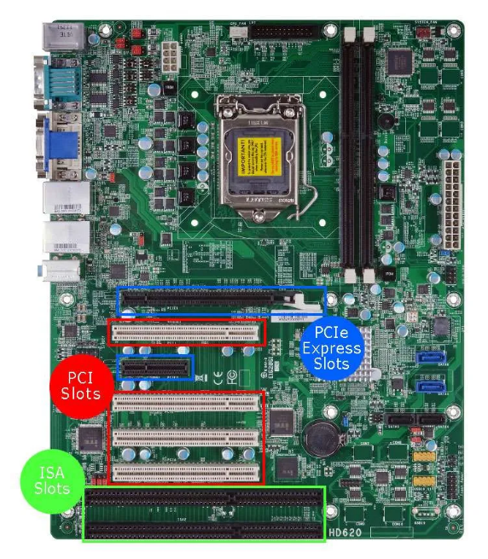A peripheral component interconnect (PCI) expansion slot is a type of slot that allows you to add additional cards to your computer system. These slots are typically used to add sound cards, network cards, or other types of interface cards.

**PCIe slot –**

A PCI express (PCIe) expansion slot is a newer type of slot that allows for faster data transfer rates than the older peripheral component interconnect (PCI) slots. PCIe slots are typically used to add graphics cards and other high-performance cards to a computer system.

**HOW TO IDENTIFY**

You can typically identify the types of expansion slots available on your computer by looking at the motherboard documentation or by physically inspecting the motherboard itself. The documentation should provide a list of the types of expansion slots available, while physically inspecting the motherboard can help you identify the specific slots available.

1. Do a practical to install the Graphics card.

Answer:-

1. Unplug your PC and open it ready for the upgrade
2. Unpack and unwrap your graphics card
3. Seat the graphics card above the vacant PCIe slot and push straight into the slot until you feel it seated
4. Tighten up bracket screws, and connect the power cables from the PSU if any are required
5. Reassemble your PC and make sure to plug your monitor into one of the ports from your new graphics card
6. Do a practical to install LAN card

Answer:-

1. Open your computer case.
2. Locate an empty expansion slot on your motherboard
3. Fix the card on the expansion slot properly
4. Close the case, and tighten the screws.

#### Topic: I/O Ports

##### Assignment Level Intermediate

1. What is I/O ports?

Answer:-

An I/O port is a socket on a computer that a cable is plugged into. The port connects the CPU to a peripheral device via a hardware interface or to the network via a network interface.

1. List out the I/O ports available

Answer:-

1. Serial port
2. Parallel port
3. Ethernet port
4. Usb port
5. Firewire port
6. Do a practical to identify the I/O ports.

Answer:-

* i/o ports are connection points that acts as an interface between the computer and external devices like mouse, keyboard, modem etc.

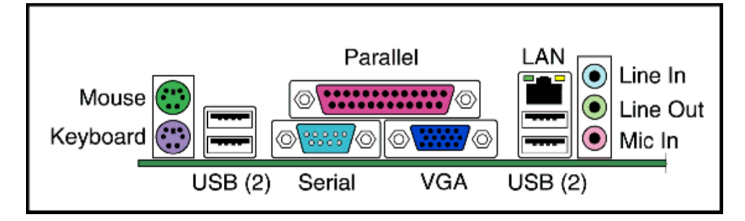

* the mouse and keyboard are connect to ps-2 port which is of 6 pin and in a circular shape.
* Usb ports are used to connect various devices that support usb cables. It has 4 pins .
* Serial port is a 9 pin port and is used to connect devices like routers.
* VGA port also known as video graphics array is a 15 pin port and monitors can connect them to the system using this.
* Sound ports are single jack ports which are used to connect microphone, stereo speakers etc.

##### Assignment Level Intermediate

1. What is I/O ports?

Answer:-

An I/O port is a socket on a computer that a cable is plugged into. The port connects the CPU to a peripheral device via a hardware interface or to the network via a network interface.

1. List out the I/O ports available

Answer:-

1. Serial port
2. Parallel port
3. Ethernet port
4. Usb port
5. Firewire port
6. Do a practical to identify the I/O ports.

Answer:-

* i/o ports are connection points that acts as an interface between the computer and external devices like mouse, keyboard, modem etc.



* the mouse and keyboard are connect to ps-2 port which is of 6 pin and in a circular shape.
* Usb ports are used to connect various devices that support usb cables. It has 4 pins .
* Serial port is a 9 pin port and is used to connect devices like routers.
* VGA port also known as video graphics array is a 15 pin port and monitors can connect them to the system using this.
* Sound ports are single jack ports which are used to connect microphone, stereo speakers etc.

#### Topic: BIOS & CMOS

##### Assignment Level Basic

1. What is BIOS?

Answer:-

BIOS is the program a computers microprocessor uses to start the computer system after it is powered on. It also manages data flow between the OS and other attached devices.

1. What is CMOS?

Answer:-

CMOS is the term usually used to describe the small amount of memory on a computer motherboard that stores the BIOS settings. Some of these BIOS settings include the system time and date as well as hardware settings.

##### Assignment Level Intermediate

1. What is the role of BIOS in i/o?

Answer:-

* The main role of an bios is to act as a middleman between i/o and operating system.

1. What is the role of i/o in CMOS?

Answer:-

The role of CMOS is to maintain time and store some settings of computer hardware in a volatile memory.

##### Assignment Level Advance

1. Do a practical to reset BIOS

Answer:-

* You will find small pins near your CMOS battery, take a jumper and fix it on them.
* Wait for 2-5 mins and remove it.
* Your BIOS is reset.

1. Do a practical to remove cmos

Answer:-

* On the motherboard, there is a circular shaped battery slot which contains a cmos battery that provides power to the cmos/bios chip.
* Remove it gently using a flathead screwdriver.

#### Topic: Laptop & storage

##### Assignment Level Basic

1. What is laptop?

Answer:-

A laptop is a personal computer that can be easily moved and used in a variety of locations. Most laptops are designed to have all of the functionality of a desktop computer, which means they can generally run the same software and open the same types of files.

1. Why laptop is used widely now a days?

Answer:-

* Its form factor is the main reason why it is widely used
* Its portable, lighter and slim

##### Assignment Level Intermediate

1. Describe the working process of laptop?
2. What is storage?

Answer:-

Storage is a mechanism that enables a computer to retain data, either temporarily or permanently.

1. List out the types of storage devices.

Answer:-

* Optical devices
* Magnetic devices
* Semiconductor devices

##### Assignment Level Advance

1. Do a practical to identify types of storage.

Answer:-

* If your storage is in a shape of circular disk and its capacity is 700mb then it is an optical storage device.
* If your storage is connected to the motherboard using a sata or pata cable, and has a capacity of 64gb,128gb then it is a hard disk drive which is a magnetic storage.
* Semi conductor storages are the oldest in use and are normally a chip on the motherboard.

1. Do a practical to disassemble and assemble the storage.

Answer:-

Lets discuss how to remove and connect RAM which is a semi conductor storage device.

**DISASSEMBLE**

1. Take out your motherboard from the case using screwdriver by following the necessary steps.
2. Now on the RAM slot, gently push the latches on the both side away so the chip is set loose.
3. Carefully take the RAM chip out.

**ASSEMBLE**

1. Take out your motherboard from the case using screwdriver by following the necessary steps.
2. Take your RAM chip make sure it fits the slot of the motherboard in question
3. Lock it with the latches on the slot. So that the chip is attached firmly on it.
4. Do a practical to install the storage devices.

Answer:-

Let us talk about CD/DVD drive. Which is an optical storage device

1. You can purchase a CD/DVD from the market, make sure it in good condition and is compatible with your system.
2. The driver is physically connected to your motherboard with cables.
3. Push the eject button on the driver, you will see the cd holder coming out.
4. Place the disk on the holder and push the button again so that it goes in.
5. Now, the read/write head will read the data on the reflecting side of the cd.

#### Topic: Printer

##### Assignment Level Basic

1. What is printer?

Answer:-

An output device that prints textual information on a piece of paper from a document on the computer system.

1. Why is printer needed?

Answer:-

Some information needs to be used in a physical format rather in digital format, that’s why printer helps converting digital data i.e soft copy into hard copy.

##### Assignment Level Intermediate

1. Describe the working process of printer.

Answer:-

A printer works by sending electronic signals from the computer to the printer's control board. The control board then interprets these signals into instructions for the print head or toner cartridge. The print head or toner cartridge prints the document or image onto paper.

1. What are the types of printer.

Answer:-

There are mainly 2 types of printers

* Impact printer
* Non-Impact printer

##### Assignment Level Advance

1. Do a practical to install the printer

Answer:-

In most cases, all you have to do to set up a printer is to connect it to your PC. Simply plug the USB cable from your printer into an available USB port on your PC, and turn the printer on.

1. On the taskbar, select the Search icon, type Printers in the search bar, and then select Printers & scanners from the search results to open the Printers & scanners system setting.
2. Next to Add a printer or scanner, select Add device.
3. Wait for it to find nearby printers, then choose the one you want to use, and select Add device. If you want to remove the printer later, select it, and then select Remove.
4. If your printer isn't in the list, next to The printer that I want isn't listed, select Add manually, and then follow the instructions to add it manually using one of the options.
5. Do a practical to Troubleshoot the improper printing.

Answer:-

* Unplug the printer
* turn off the computer and restart both the devices.
* Once the devices have restarted, run a self-test page.
* If it still doesn’t print properly, the problem could be with the printer, toner, drum unit, or roller.

#### Topic: Storage devices

##### Assignment Level Basic

1. What is storage device?

Answer:-

Storage is a mechanism that enables a computer to retain data, either temporarily or permanently.

1. Why we need storage device

Answer:-

The importance of storage devices is that they can retain almost all the data and applications in a device. Depending on its demand or performance, it comes in various sizes and shapes. It can retain information for the short term and the long term. A storage device needs to reserve or store your important data.

##### Assignment Level Intermediate

1. List out the types of storage devices.

Answer:-

* Optical devices
* Magnetic devices
* Semiconductor devices

1. Describe the working process of storage devices.

Answer:-

storage devices stores information, the processor is connected to storage such as main memory directly as it stores important data so that the system works properly. The storage devices sends electrical signals containing data on the system bus which travels to the processor to be processed and then to the output devices.

##### Assignment Level Advance

* 1. Do a practical to Remove storage devices and reinstall it and make a gpt disk.

Answer:-

**REMOVING DEVICE**

* type diskmgmt. msc in the search or run window and then press enter.
* Right-click the disk you wish to remove and select Offline to turn off the device.

**REINSTALL AND MAKING A GPT DISK**

* Back up or move the data on the MBR disk prior to conversion.
* Delete all partitions and volumes on the MBR disk.
* For each partition or volume, select and hold (or right-click) the item, and select Delete Partition or Delete Volume.
* Select and hold (or right-click) the MBR disk to convert to the GPT format, and select Convert to GPT Disk.

#### Topic: ATA

##### Assignment Level Intermediate

* 1. What is ATA?

Answer:-

Advanced Technology Attachment (ATA) is a standard physical interface for connecting storage devices within a computer. ATA allows hard disks and CD-ROMs to be internally connected to the motherboard and perform basic input/output functions.

##### Assignment Level intermediate:

* 1. Describe working of ATA.

Answer:-

ATA uses a parallel interface to transfer data between the storage device and the computer, with a maximum transfer rate of 133 MB/s. The ATA standard includes both a physical interface and a protocol for communication between the device and the computer.

##### Assignment level Advanced:

* 1. Do a practical to identify and install ATA cables.

Answer:-

**HOW TO IDENTIFY?**

The maximum length of ATA cables is 457mm and that is the reason it normally appears as an internal computer storage interface, the cable has 40 pins(in a 20x2 matrix).

**HOW TO INSTALL?**

1.Make sure your motherboard supports a ATA port or PATA port.

2.Take your cable and connect it to the motherboard.

3.connect the other end with the Hard disk supporting ATA.

#### Topic: SATA

##### Assignment Level Basic

1.What is SATA?

Answer:-

SATA, in full serial advanced technology attachment, also called serial ATA, an interface for transferring data between a computer's central circuit board and storage devices.

##### Assignment Level Advance

1. Describe the working of SATA.

Answer:-

The cables allow drives to exchange data through the motherboard with the computer; SATA cables can transmit data faster than the older EIDE ribbon cables. Although SATA drives perform at a higher speed, the data transferred through the device is the same. SATA cables are thinner, flexible, and not as flexible as the conventional ribbon cables used by PATA hard drives. There are two sides to the SATA cable: the signal and power cable.

The signal cable comes with seven conductors in a flat cable. Two conductors are for sending information, while two are for receiving. When the computer reads from the disk or writes data to the storage device, the signals sent by the computer go through the SATA signal cables. The power cables are quite similar in construction but have 15 conductors. Their goal is to supply power to the optical or hard drive.

1. Do a practical to identify sata.

Answer:-

The power connector has 15pins while the data connector has 7 pins. Its interface is smaller than PATA.

1. Do a practical to install SATA.

Answer:-

1.Make sure your motherboard supports a SATA port.

2.Now, take your SATA data cable and connect with the hard drive or ssd.

3.connect the other end on the motherboard.

4.the 15 pin power SATA cable is connected to the drive and the other end to the power supply.

1. Where does SATA is used.

Answer:-

SATA is used to connect

* Hard disk drives
* Optical drives
* Solid state drives

to the motherboard.

#### Topic: SCSI

##### Assignment Basic

1. What is SCSI?

Answer:-

SCSI is small computer system interface that allows connection between the pc and many other peripheral devices.

1. WHy SCSI needed?

Answer:-

SCSI supports a wide range of device types, and external SCSI devices offer advantages such as faster data transfer rates and the ability to connect multiple devices in a daisy-chain configuration.

##### Assignment level Intermediate:

1. What is the rpm of SCSI?

Answer:-

10,000 – 15,000 rpm.

1. Do a Practical to install scsi.

Answer:_

* 1. Open your system unit, and take your motherboard.
  2. You will find empty PCI slots on the board
  3. Take your SCSI card and fix it inside the PCI slot.
  4. Now, you can connect any device that supports SCSI connection to your system.

#### Topic: Laptop

##### Assignment Level Basic:

1. What is laptop?

Answer:_

A laptop is a personal computer that can be easily moved and used in a variety of locations. Most laptops are designed to have all of the functionality of a desktop computer, which means they can generally run the same software and open the same types of files.

1. What are the types of laptop?

Answer:-

1. Diffrent names of laptop.

Answer:-

* Microcomputer
* Minicomputer
* Notebook
* palmtop

##### Assignment level Intermediate:

1. What are the parts of laptop?
2. Do a practical of identifying parts of the laptop.

##### Assignment level Advance.

1. Do a practical to disassemble the laptop.

Answer:-

* Turn off the computer
* Remove back panels
* Remove components
* Remove hinge cover plate
* Remove laptop screen
* Remove screws
* Pry case apart

1. Do a practical to change the RAM in the laptop.

Answer:-

* 1. Turn off and unplug your laptop.

2. Remove or loosen necessary screws and then take off the base. Now, we're ready to get to the RAM.

3. Locate the RAM. SO-DIMMs are typically held in by some clips.

4. Remove your old RAM. Gently (but firmly) press down and outward on the clips until the RAM stick releases. It will point up at an angle, and can be safely removed. If you are just adding a stick in an empty slot, you can skip this step.

5. Put in your new RAM. Hold the RAM by the sides and insert it into the slot at an angle. Be sure to align the notch in the middle with the notch on the slot. If it's not aligned, you may have to flip the RAM stick over.

6. Press down on the new RAM. It should click into the clips. If it doesn't, reseat the RAM and try again.

7. Close up your laptop and power it on.

8. Check that the RAM was installed. Go into Settings > System > About and see how much RAM is installed in your laptop. If you don't see the full amount, open the laptop back up and reseat the RAM.

#### TOPIC: PRINTER

##### ASSIGNMENT LEVEL BASIC:

1. WHAT IS PRINTER?

Answer:-

An output device that prints textual information on a piece of paper from a document on the computer system.

1. IS IT A INPUT DEVICE OR OUTPUT DEVICE?

Answer:-

It is an output device.

##### Assignment level intermediate:

1. Describe the types of printer.

Answer:-

* **Impact printer:-**

These printers have a mechanism that touches the paper to create an image. These printers work by banging a print head containing a number of metal pins which strikes an inked ribbon placed between the print head and the paper.

For example, dot matrix printer.

* **Non-impact printer:-**

These printers create an image on the paper without using force. They don’t touch the paper while cresting an image. Non-impact printers are much quieter than impact printers as they don’t strike the paper.

For example, laser printer, inkjet printer etc.

1. Describe inkjet printer.

Answer:-

It is a non-impact printer producing high quality print. A standard inkjet printer has a resolution of 300dpi. Newer models have further improved dpi. Inkjet printers were introduced in the later half of 1980s and are very popular owing to their extra-ordinary performance.

##### Assignment level Advanced:

1. Do a practical of network installation of the printer.

Answer:-

1. Connect the printer with your primary pc using usb or any other cable.
2. Turn on the printer and the pc.
3. Select the Start  button, then select Settings  > Devices > Printers & scanners.
4. Choose the printer you want to share, then select Manage.
5. Select Printer Properties, then choose the Sharing tab.
6. On the Sharing tab, select Share this printer.
7. If you want, edit the Share name of the printer. You'll use this name to connect to the printer from a secondary PC. When you are done, select OK.
8. do a practical to troubleshoot the printer of no cartridge error

Answer:-

1. Remove all of the new cartridges you had installed and re-install the old(empty) cartridges that worked.
2. Restart the printer, this should remove the not recognised error (and tell you some are empty).
3. Install oneof the new cartridges then keep installing the new cartridges one-by-one until the error returns and you can then identify the cartridge that's causing the problem.